Greco Feudal UX Report

# Hypothesis

Due to the increase in game complexity, there is a lack of local competitive games that can be played on one keyboard.

# Challenge

When you visit a friend and want to play a quick competitive experience, modern games are too complicated. There are too many controls and you often need multiple controllers.

# Approach

To make sure my game was reaching my hypothesis I had to test whether it felt competitive, and whether it was easy to play with another person locally. My approach to this was to have people play the game and then answering a questionnaire plus some follow up questions.

After the feedback I planned to act on any emergent problems, flesh out a persona with the collected data, and decide futures actions to make the game reach my hypothesis.

# Experiment

To see if my hypothesis is valid, I built a working prototype of my game. In the tests I had two people on one keyboard playing against each other. The desired experience was a fast paced competitive runner leading up to a fast paced clash. Diagram

When questioned afterwards, some players felt that the competitive nature was not apparent enough in this incarnation and that you feel too uninvolved with the other player. All the play testers felt that the game was fast paced and easily playable with a friend locally on one keyboard.

These results showed that I had not yet fully reached my goal of answering the hypothesis.

# Results

I categorised the questionnaire feedback into an affinity map.

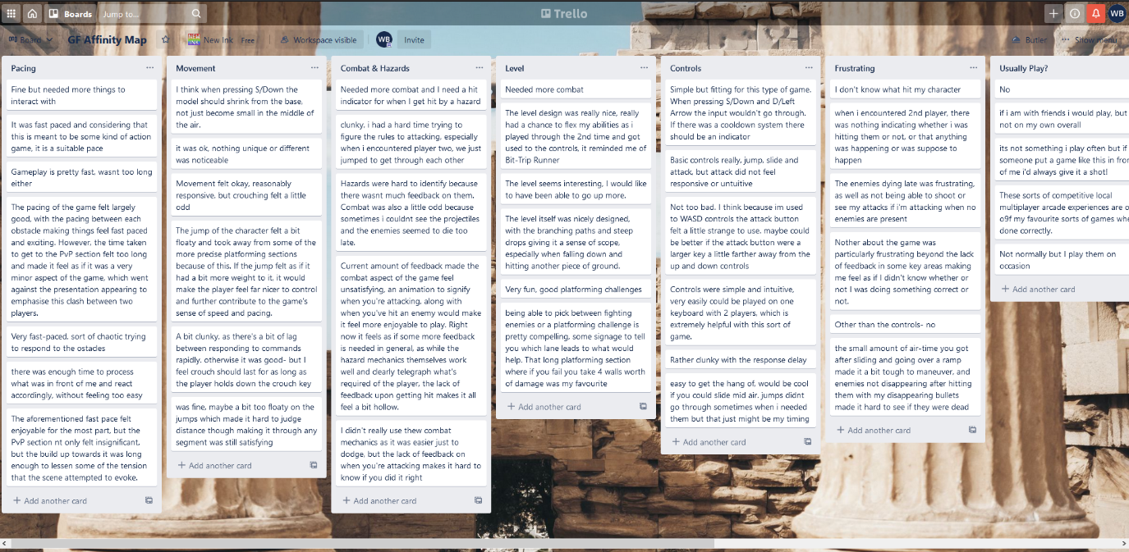

I then turned the information into relevant motivations, needs, goals, & frustrations that are more meaningful.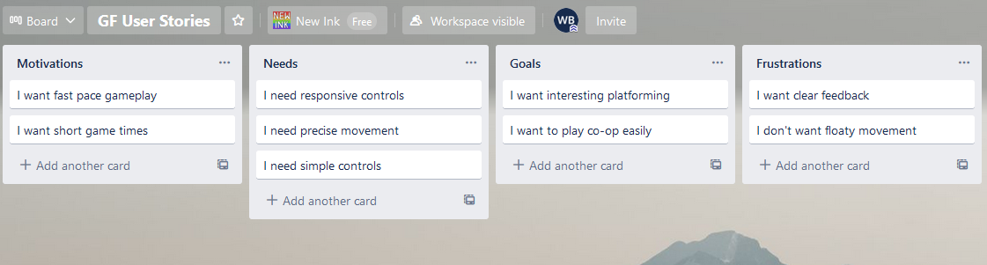Lastly, I created a persona from the user feedback to focus game design decisions around aspects that matter. 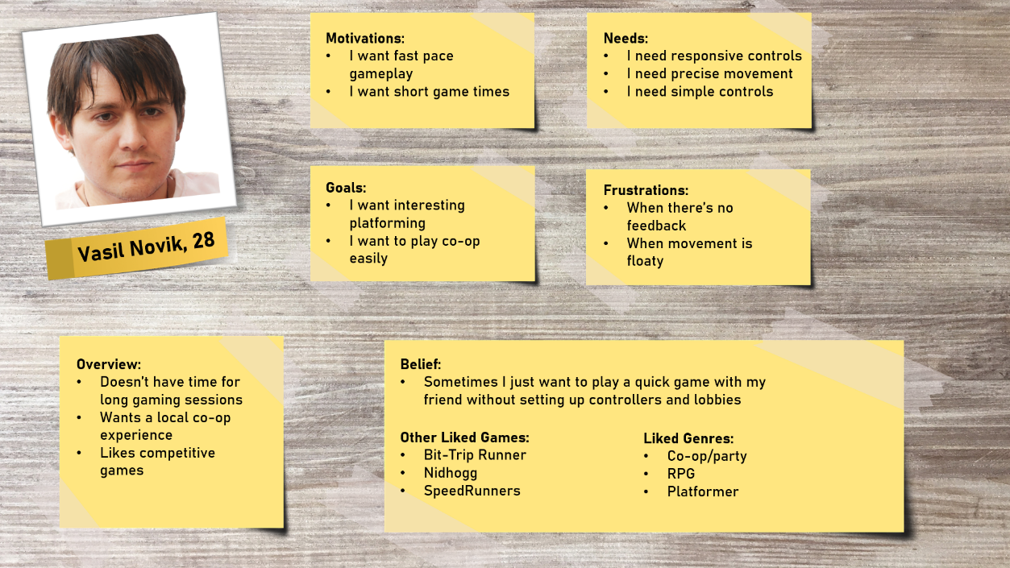

Amendments

Make the game

Conclusion

In conclusion, this project was a success as people resonated with my hypothesis and found it easy to play with one another on the same keyboard. With some changes to the gameplay based on feedback it will also achieve the competitive nature that was being aimed for.

[Maybe add what I’m going to be changing here.]

~~Hypo~~

Come up with plan

Do plan/test

questionnaire

~~Write up affinity map~~

~~Make persona~~

Make changes to game

Success or failure